Ideations:
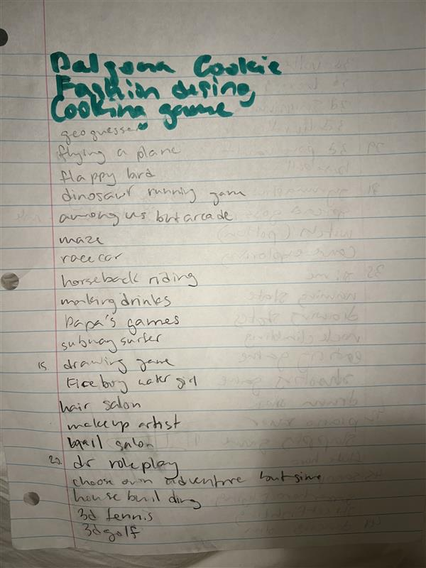
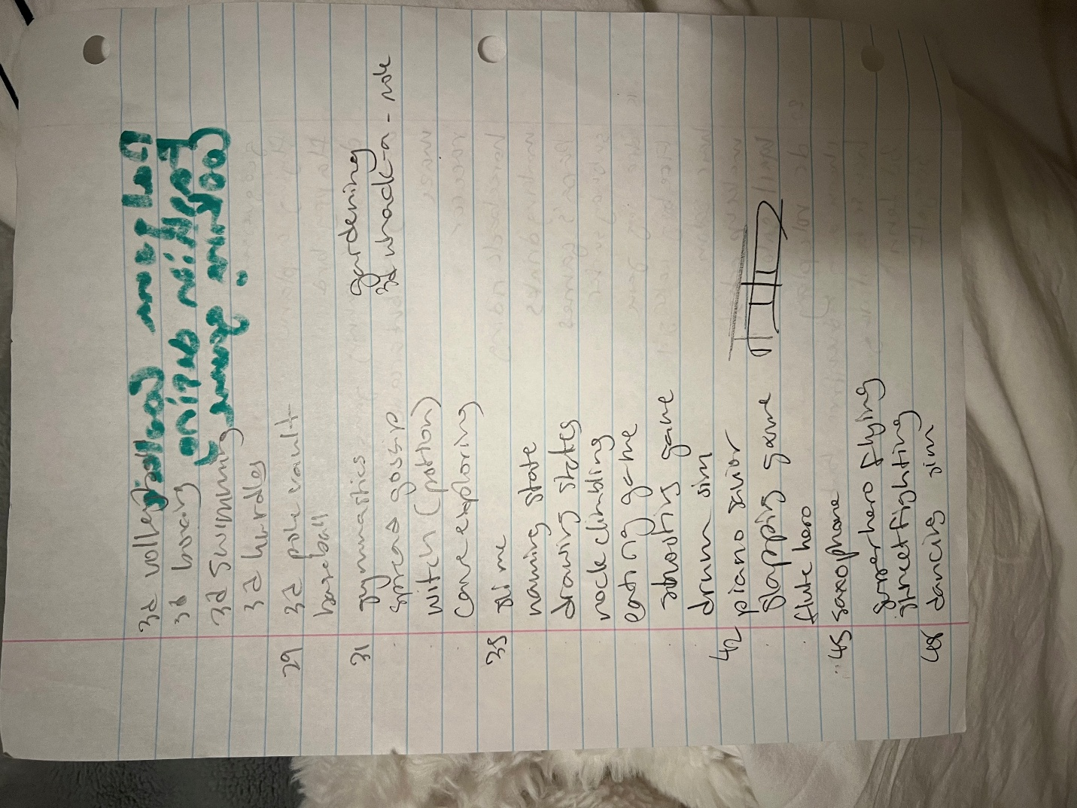
Block Diagrams:
- Superman Game
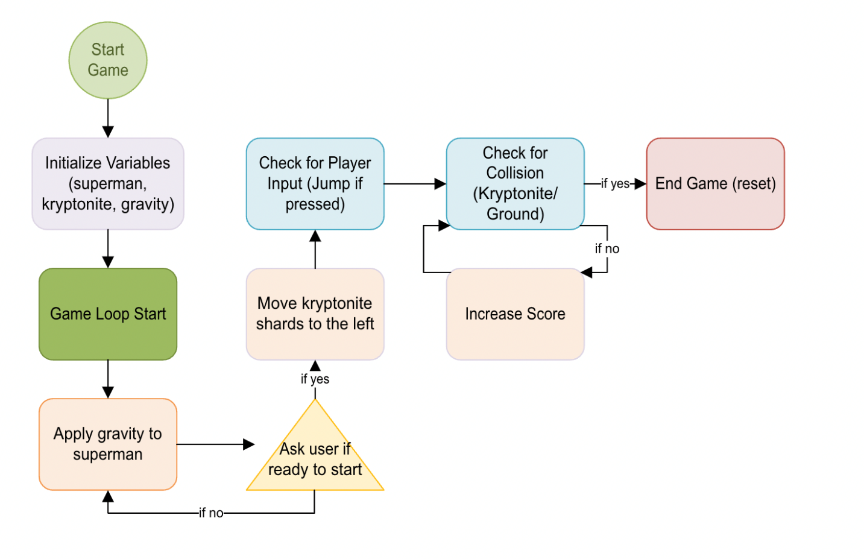
- Maze Game
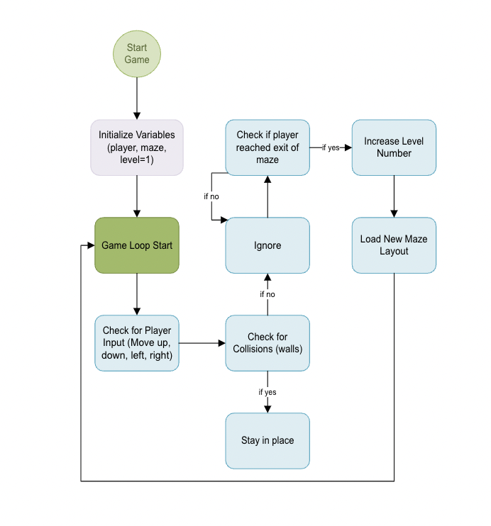
- Sundae Game
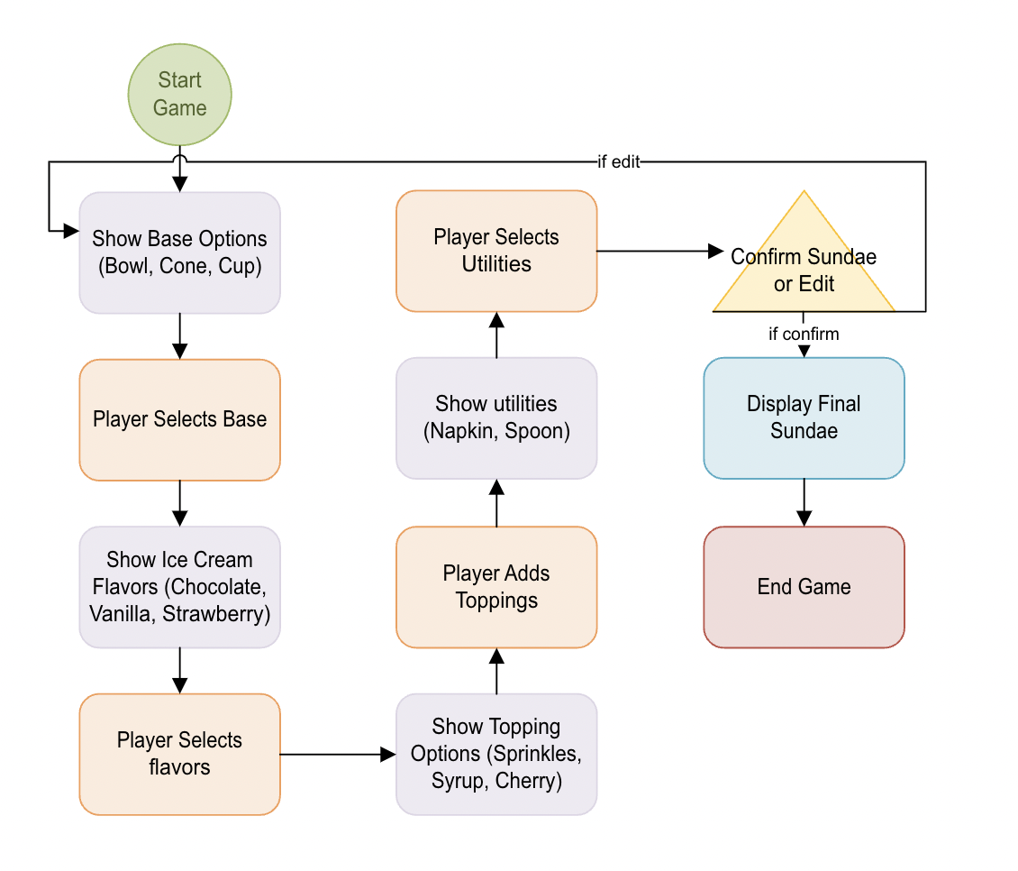
2 Info Collections:
Superman Game:
- Characters
  - Superman (flying animation)
  - Villain (robots, aliens, lex luthor’s minions)
  - Citizens (falling, trapped, etc)
- Background
  - City skyline (3d or 2d scrolling background)
  - Buildings (skyscrapers, apartments, etc)
  - Clouds (moving with skyline)
  - Sun & Sky transitions (day and night)
- Game objects
  - Kryptonite
    - Drains power/ kills superman
  - Power-ups (extra strength, speed, shields)
- UI
  - Health bar
  - Score counter
  - Power up indicators
  - Level progress tracker
- Sound effects
  - Flying sound
  - collision sounds
  - heroic music
- Player Input
  - Arrow keys (movement)

Sundae Game:
- Game objects
  - Base options (bowl, cone, cup)
  - Ice cream flavors (Chocolate, vanilla, strawberry)
  - Toppings (Sprinkles, syrup, cherries)
  - Utensils (spoon, napkin)
- Background
  - Ice cream parlor
  - Countertop where sundae sits
  - Menu screen with flavor/topping choices
- UI
  - Selection menus for base, flavors, toppings
  - “confirm” and “edit” buttons
  - Score system (for accuracy)
- Sound effects
  - Ice cream scooping sound
  - Toppings falling sound
  - Store background music
- Player Input
  - Confirmation button
  - Joystick for moving around choices

